Fractional distillation synoptic questions

Learning objectives
- To recall prior learning on bonding, structure and the properties of matter and changes of state.
- To apply this prior learning in the context of fractional distillation.

Introduction

To understand the processes involved in fractional distillation you need to have a secure understanding of a number of concepts including bonding, structure and the properties of matter and changes of state.

The questions in this worksheet ask you to retrieve relevant knowledge and understanding from prior learning then apply it in the context of fractional distillation.

Questions
- State the number of protons, neutrons and electrons in an atom of carbon ${}_{6}^{12}C$.

Protons = __________

Neutrons = __________

Electrons = __________
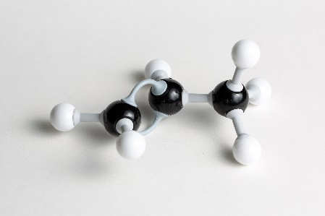
- Give the molecular formula for the hydrocarbon modelled in the image.

Black = C; white = H.

_________________________________

- Octane $C_{8}H_{18}$ is found in petrol. Calculate the amount of moles in 28.5 g of octane.

Atomic masses in $g {mol}^{-1}:$ C = 12, H = 1

Number of moles = __________

- Methane, $CH_{4}$ is a simple covalent molecule. Draw a dot and cross diagram to represent the bonding in methane.

- Explain what holds the atoms together in a covalent bond.

__________________________________________________________________________________

__________________________________________________________________________________
__________________________________________________________________________________

- Alkanes have the general formula $C_{n}H_{2n+2}$. State the formula of an alkane containing 28 carbon atoms.

_________________________________

- Propane has the molecular formula $C_{3}H_{8}.$ Use your understanding of the fractional distillation process and the structure and bonding in propane to explain why propane is collected as a gas from the top of the fractional distillation column.

__________________________________________________________________________________

__________________________________________________________________________________

__________________________________________________________________________________

- Write a balanced symbol equation for the complete combustion of propane, $C_{3}H_{8}$.

__________________________________________________________________________________

- Heptadecane $C_{17}H_{36}$ is found in diesel. It has a boiling point of 302 °C. What is the state of heptadecane at the point in the fractional distillation column where the temperature is 350 °C. Tick one box only.

☐ Solid
☐ Liquid

☐ Gas

- The combustion of a fuel such as diesel is an example of an exothermic reaction. Complete the reaction profile for an exothermic reaction:
- label the y-axis;
- draw a horizontal line to represent the energy of the products;
- label the overall energy change in the reaction.

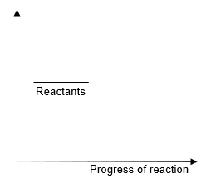

- An equation for the complete combustion of methane is given below.

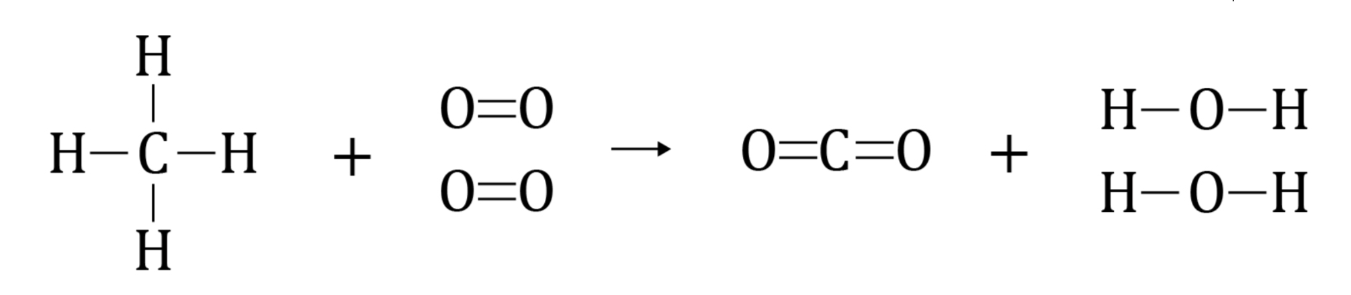

Use the bond energies in Table 1 to calculate the energy change for the reaction.
Bond | Bond energy $(kJ {mol}^{-1})$
C–H | 413
O=O | 498
C=O | 805
O–H | 464

Table 1

Energy change = __________

- Describe the trend in the flammability of the hydrocarbon fractions as the chain length increases.

__________________________________________________________________________________

__________________________________________________________________________________

__________________________________________________________________________________

- Describe and explain the trend in the viscosity of the hydrocarbon fractions as the chain length increases.

__________________________________________________________________________________

__________________________________________________________________________________

__________________________________________________________________________________

