Bar Graph showing concentrations of species in solution
(water is not included in these graphs as it has a very high concentration of 55.5 molL⁻¹)

The salts below dissolve fully in water,
there are many ions free to move and carry a charge, so these aqueous solutions are good electrolytes
pH = 7 as [H₃O⁺] = [OH⁻]
NaCl  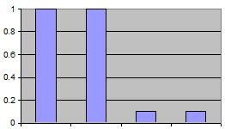  H₃O⁺  Cl⁻  Na⁺  OH⁻  NaCl _{(s)} Na⁺ _{(aq)} + Cl⁻ _{(aq)}  there is no such thing as NaCl (aq) | CaCl₂  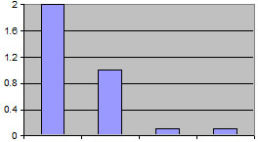  OH⁻  H₃O⁺  Ca²⁺  Cl⁻  CaCl_{2(s)} Ca²⁺_{(aq)} + 2Cl⁻_{(aq)}  notice that conc of Cl⁻ ions is twice  OH⁻  Cl⁻  conc Ca²⁺ ions | CaSO₄  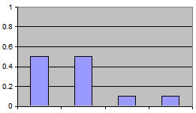  Ca²⁺  SO4²⁻  OH⁻  H₃O⁺  CaSO_{4(s)} Ca²⁺ _{(aq)} + SO₄²⁻_{(aq)}  Na⁺  CaSO₄ is only slightly soluble  so all concentrations are lower

The following solutions all have [OH⁻] > [H₃O⁺] so the pH > 7
They are also good electrolytes as there are ions free to move in solution and carry a charge
CH₃COONa in water  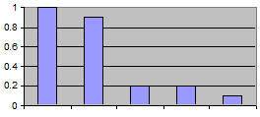  CH₃COO⁻  H₃O⁺  OH⁻  Na⁺  CH₃COOH  CH₃COONa_{(s)} Na⁺_{(aq)} + CH₃COO⁻_{(aq)}  CH₃COO-_{(aq)} + H₂O ⇌ CH₃COOH_{(aq)} + OH⁻_{(aq)} | NaOH in water  strong base  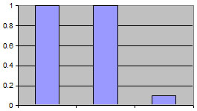  H₃O⁺  Na⁺  OH⁻  NaOH_{(s)} Na⁺_{(aq)} + OH⁻_{(aq)} | Ca(OH)₂ in water  strong base  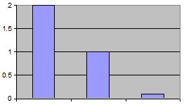  OH⁻  Ca²⁺  H₃O⁺  Ca(OH)_{2(s)} Ca²⁺_{(aq)} + 2OH⁻_{(aq)}
NH₃ in water
weak base
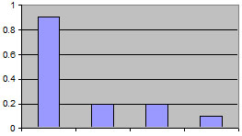
OH⁻
NH₃
NH₄⁺
H₃O⁺

NH_{3(aq)} + H₂O ⇌ NH₄⁺_{(aq)} + OH⁻_{(aq)}

The following solutions all have [H₃O⁺] > [OH⁻] so the pH < 7
They are good electrolytes as there are ions free to move in solution and carry a charge
HCl in water  a strong acid  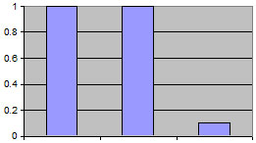  OH⁻  Cl⁻  H₃O⁺  HCl_{(aq)}+ H₂O H₃O⁺_{(aq)} + Cl⁻ _{(aq)} | CH₃COOH in water  a weak acid  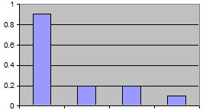  CH₃COO⁻  H₃O⁺  OH⁻  CH₃COOH  CH₃COOH_{(aq)} + H₂O ⇌ CHCOO⁻_{(aq)} + H₃O⁺_{(aq)} | NH₄Cl in water  a salt  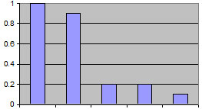  Cl⁻  NH₄⁺  H₃O⁺  NH₃  OH⁻  NH₄Cl_{(s)} NH₄⁺_{(aq)} + Cl⁻ _{(aq)}  NH₄⁺ _{(aq)} + H₂O ⇌ NH_{3(aq)} + H₃O⁺_{(aq)}  Ca²⁺

very soluble in water  but a poor conductor of electricity as there are few free ions to carry a charge  neutral pH |  | insoluble  poor conductor of electricity  neutral pH
CH₃CH₂OH  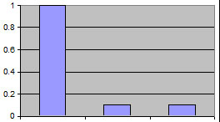  CH₃CH₂OH  H₃O⁺  OH⁻  CH₃CH₂OH_{(l)} CH₃CH₂OH_{(aq)} |  | C₆H₁₂  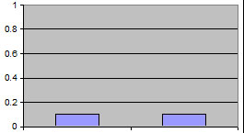  OH⁻  H₃O⁺  as cyclohexane is insoluble,  the concentrations of species present  in water is unchanged

Reference: edited from http://moodle.lynfield.school.nz/mod/resource/view.php?id=11521
© 2018 https://www.chemical-minds.com

