The basics of boiling

The type of bond (like glue!) that holds the atoms together in a molecule is very strong. It is called a
covalent bond. However, the force between molecules is very weak. It is called a weak intermolecular
force.
Make molecules of water using plasticine and toothpicks and place them into a glass/mug.
Try to complete the diagrams below, sketch using to represent H atoms and to represent O atoms.
molecules of water in a beaker | boiling | molecules of water in the air  after being heated above 100’C

A common misconception is that the atoms of oxygen and hydrogen separate from each other when water boils. However, as water molecules are heated the atoms of oxygen and hydrogen do not separate from each other.
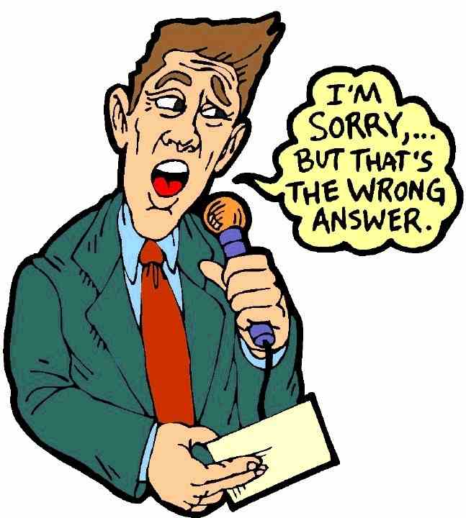
Questions
1. Why do you think atoms of O and H are not able to separate from each other?
(tip: think about the bonding)
_______________________________________________________________________________________
As water is heated the molecules of water do separate from each other.
2. Why do you think this is? (think about the forces between the molecules)
_______________________________________________________________________________________
So, to conclude, the atoms in a molecule of water do not separate from each other because the covalent
bonds between the atoms are very strong. However, the weak intermolecular forces between the
molecules do break so the water molecules can move around freely with high energy and separate from
each other. This is also the case for a substance that is melting, forces between particles must be broken.
State the change of state as water is heated ___________________________________________________
Describe what you see as the molecules of water in the kettle are heated ____________________________
_______________________________________________________________________________________
_______________________________________________________________________________________
Explain (in terms of bonding and forces) the changes that occur to the water molecules as the beaker of
water is heated __________________________________________________________________________
_______________________________________________________________________________________
_______________________________________________________________________________________
_______________________________________________________________________________________

