Types of organic reactions

2019
1. (a) Explain how acidified potassium permanganate solution, KMnO₄ / H⁺(aq), can be used to distinguish
between compounds A (alkene) and B(alkane).
In your answer you should
• identify the type of reaction
• describe any relevant observations.
(b) Compounds A and B will both react with bromine water, Br₂(aq).
Compare and contrast these reactions by referring to the conditions required, the observations, the products
formed, and the type of reaction.

2. Compare and contrast the reaction that forms compound B to the reverse reaction that forms propene, C₃H₆, from compound B.
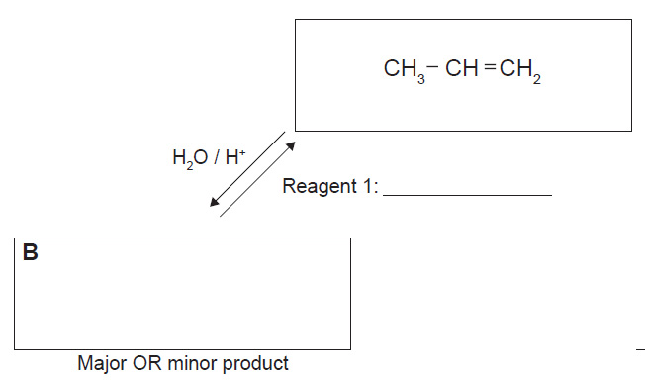

2018
Reacting 2-chloropropane with potassium hydroxide, KOH, can produce different products due to different
reactions occurring.
Elaborate on the reactions of 2-chloropropane with potassium hydroxide, KOH.
In your answer you should:
• identify the conditions of the reagent KOH
• explain the types of reaction that occur with the reagent in each condition
• draw structural formulae of the organic products.

2017
Alkanes and alkenes can be identified by their reactions with a solution of bromine water, Br₂(aq).
Contrast the types of reactions an alkane and an alkene will undergo with an orange solution of bromine water.

2015
Ethene, C₂H₄(g), reacts with aqueous potassium permanganate solution, KMnO₄(aq), dilute acid, H₂O / H⁺, and hydrogen bromide, HBr.
Compare and contrast the reactions of ethene gas with each of these three reagents.
In your answer, you should:
• describe any observations that can be made
• identify, with reasons, the type of reaction ethene undergoes with each reagent
• describe the functional group of the products formed
• include equations showing the structural formulae for the organic compounds for each reaction.

2014
1. The reactions shown below are all classified as being the same type of reaction.
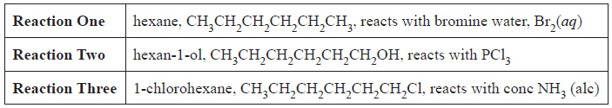
Compare and contrast these reactions.
In your answer you should:
• state whether any conditions are required
• describe the type of reaction occurring and explain why all three reactions are classified as this type of
reaction
• explain why two layers form in Reaction One.

2. Sodium carbonate, hydrochloric acid, and sulfuric acid are each added to separate samples of three
organic compounds.
The structures of the compounds and the products of any reactions are given in the table below.
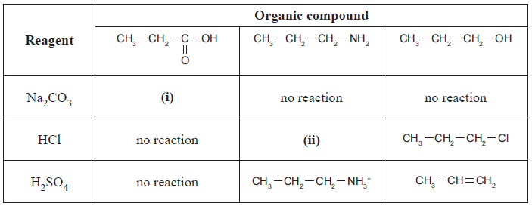
Compare and contrast the reactions that do occur between these organic compounds, and the reagents in the
table above.
In your answer you should:
• give the structure of the organic products (i) and (ii)
• describe the different types of reactions occurring, and give reasons why they are classified as that type
• identify any specific conditions that are required for the reactions to occur.

3. i) Explain why Reaction 1 from the reaction scheme, shown again below, is classified as an addition reaction.
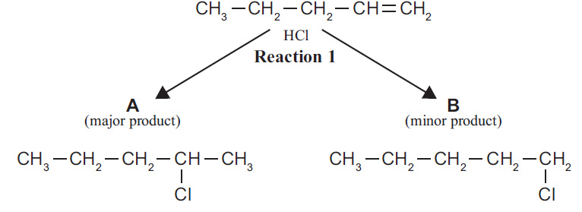
ii) Explain why the reaction shown below, is classified as an elimination reaction.
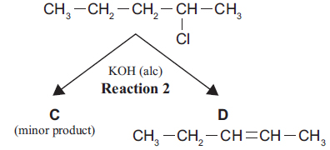

iii) The reaction below is also an elimination reaction. Draw the structural formula of the product formed
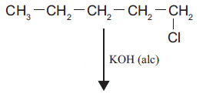

2013
Butan-1-ol can react separately with each of PCl₅, Cr₂O₇^{2–}/ H⁺, and concentrated H₂SO₄.
Elaborate on the reactions of butan-1-ol with each of the three reagents.
For each reaction, your answer should include:
the type of reaction occurring and the reason why it is classified as that type
the name of the functional group formed in each product
the structural formula of the organic product.

https://www.chemical-minds.com
NCEA questions and answers reproduced with permission from NZQA

